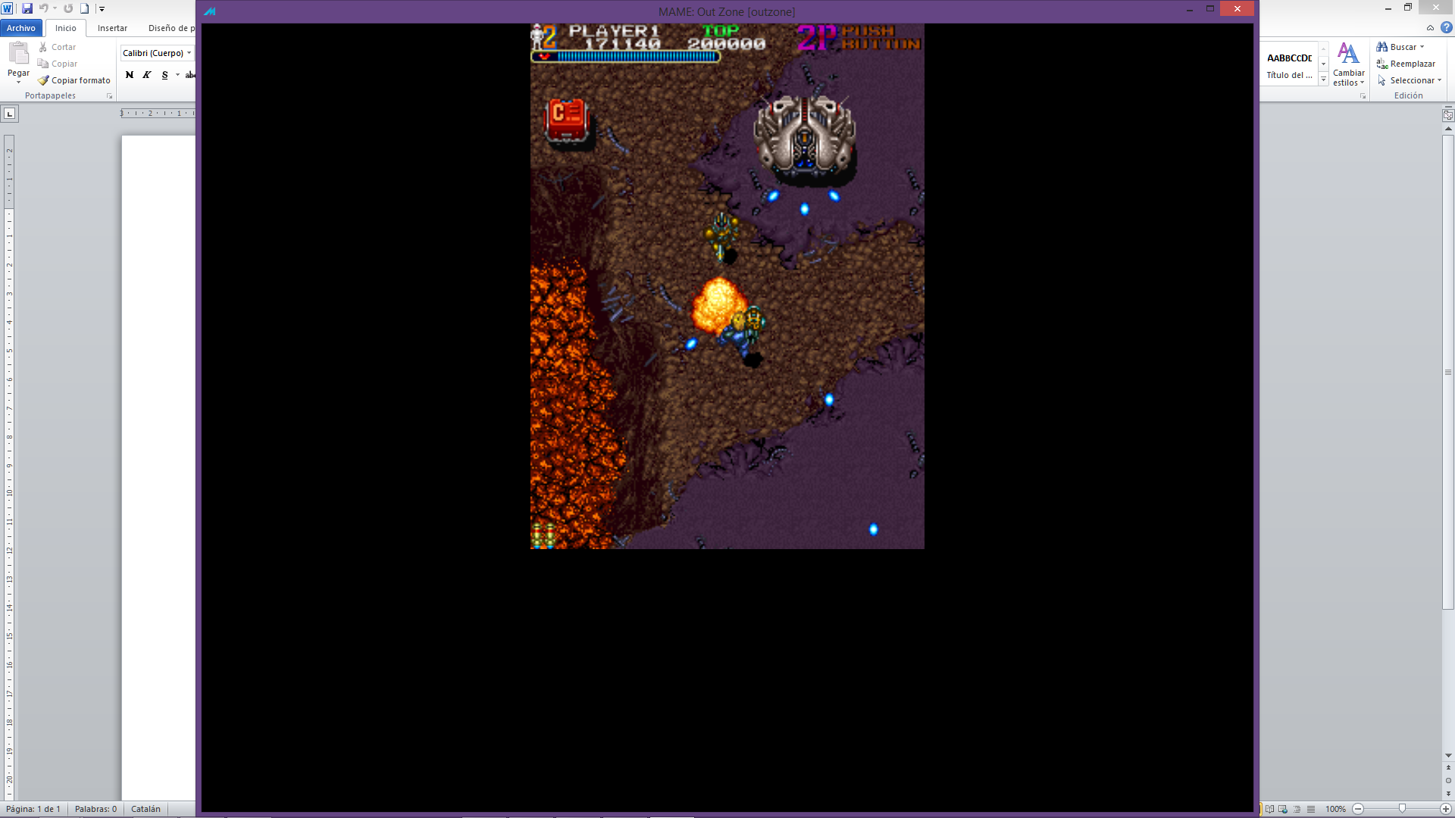 Shield tank: while shielded shots a triple shot to the Player, when the shield breaks shoots a ràpid succession of 4 shots to the Player.

Triple shot delay: About 1 sec

Rapid shot delay: About 1 sec.

Rapid shot delay(succession): about 0.1sec

 Act the same way as the lvl infatary.

Shot delay: Between 3 to 4 seconds

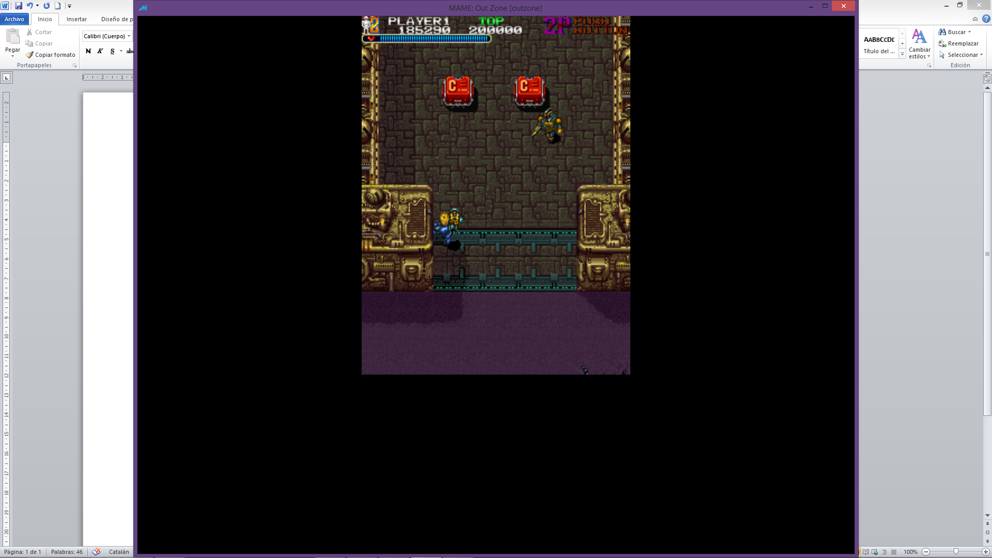 Long laser turrets: Shots a long in a fixed direction.

Shot delay: 4.5 sec

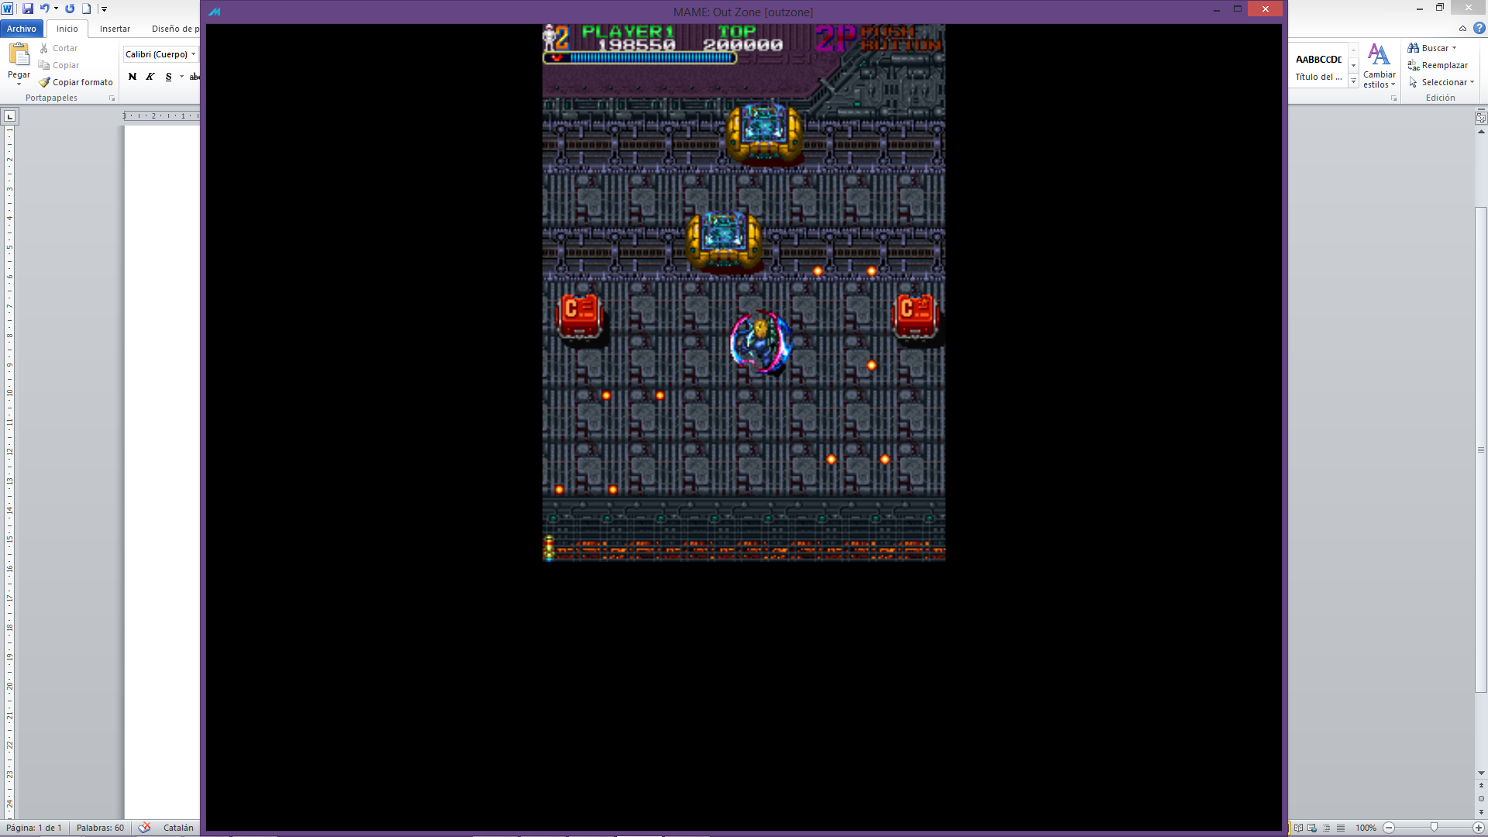 Horizontal moving Machine: Shots 3 pairs of shots at the Player, one from each side at a ràpid succesion.

Shot delay (ràpid succesion): about 0.3 sec, maybe a little less.

Shot delay(each set of 3): 1 sec

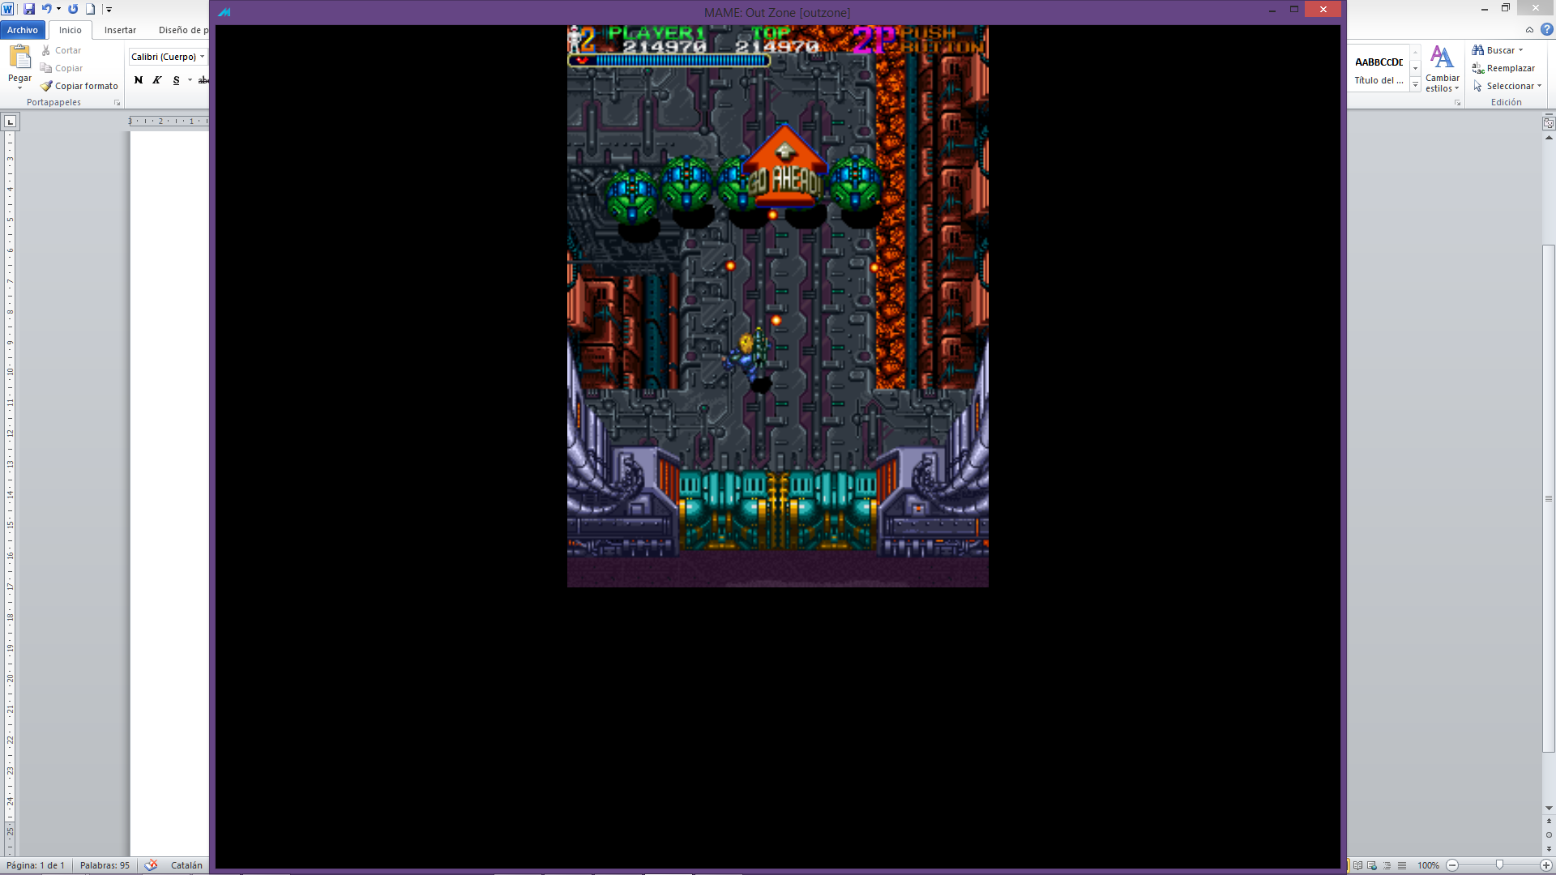 Worm: 5 diferent capsules each one, damage Shared (the damage done to one capsule aplies to all of the worm). Shots one shot from each capsule.

Shot delay: About 4 sec, shots evry time it does a loop.

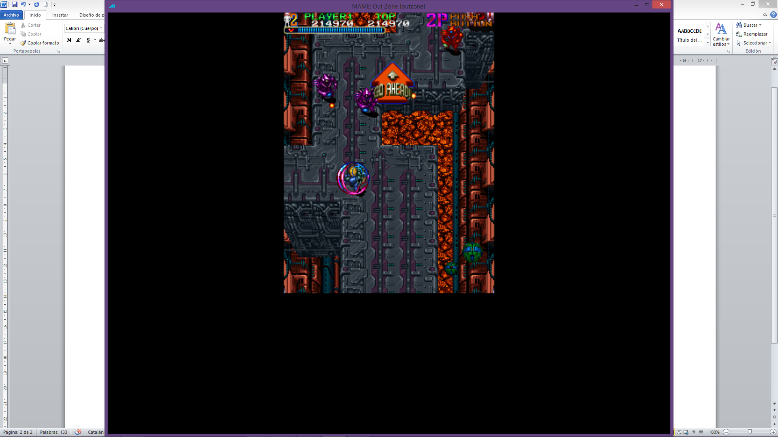Lvl q enemi with purple recolor.

Shot delay: about 0.5 sec maybe a little more

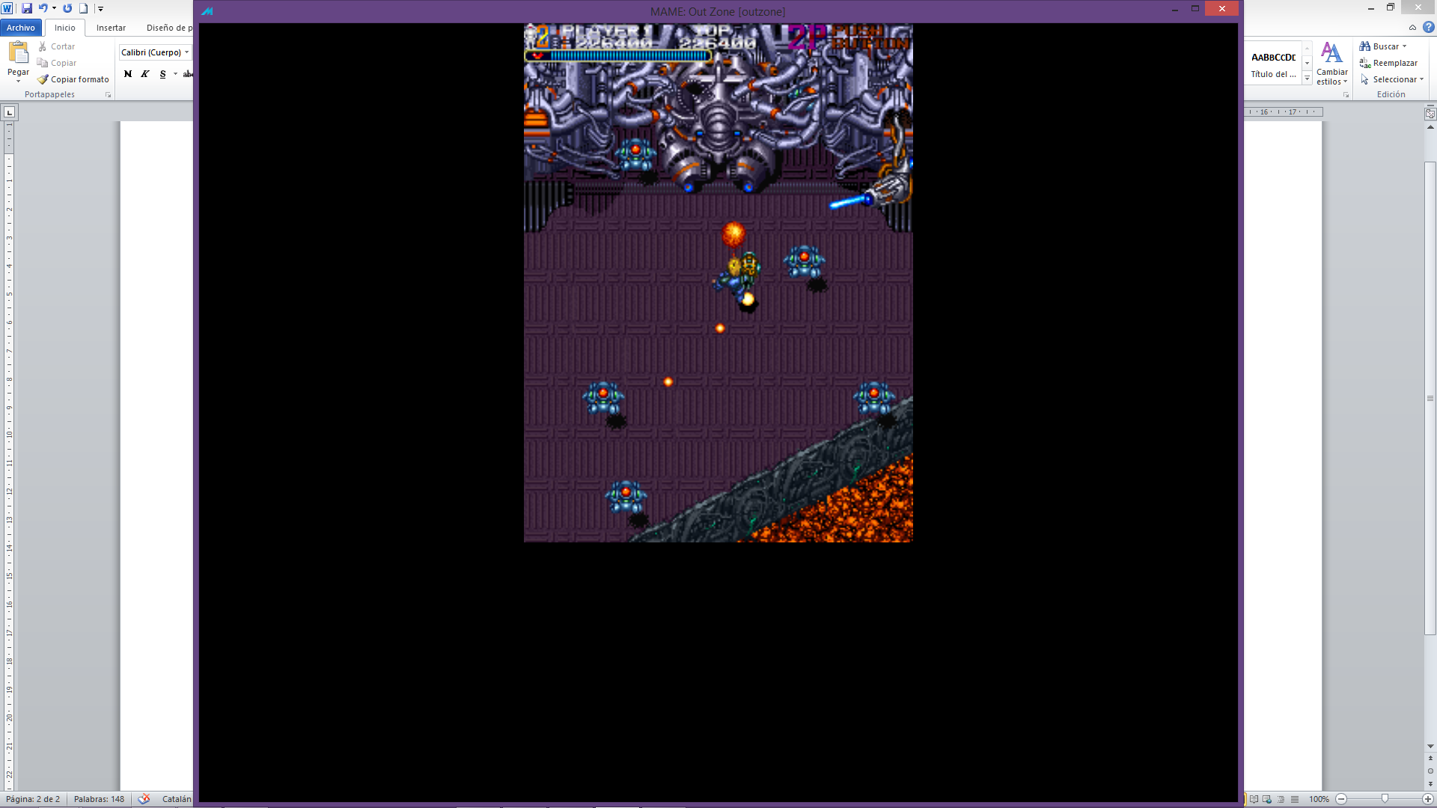Flies, not affected by lava collisions.

Shot delay: about 1 sec.

**Boss**

The side laser that break the terrain.